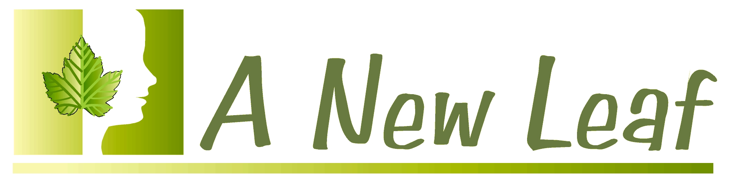
Intake form

Date of intake: ___________

Name: ________________________________________________________

Age: _____ Birthday (Month / Day) ___ / ___
Home Phone Number:________________________________________

Work Phone Number:________________________________________

Text Number if Available:________________________________________

What is the best way to reach you during the day?
___ Home Phone ____ Work Phone ___ Text ___ Email

Email Address: ________________________________________

How did you hear about A New Leaf Hypnosis?

How would you describe your spiritual beliefs?
___ Christian
___ Jewish
___ Muslim
___ Metaphysical
___ Agnostic
___ Atheist
___ Other _____________
___ Prefer not to say
Please describe the issue you would like to work on.

How long has this been an issue?

Do you remember what was happening in your life at that time?

What are you currently doing to address this situation?

How have you tried to resolve this issue in the past?

Why didn’t it work?

What emotions are related to this behavior?

What thoughts do you have which are related to this issue?

Have you ever been hypnotized before? Y/N

If so, what was your experience like?

Are there other things that you would like to work on sometime?

If you were able to resolve this situation, how would that help you? What could you do and how would you feel that would be any different from now?
Name 7 Benefits

1.

2.

3.

4.

5.

6.

7.

Can you think of any ways this behavior may be benefiting you? (Y/N)

If so, how?

Please describe to me what type of imagery is most relaxing to you – whether it be indoors or in nature, at the ocean, in a meadow, a forest – whether you prefer imagery which includes bright sunlight and warmth or cool breezes, etc. If it’s easier, feel free to bring in photographs of your favorite imagery. You may also let me know if you find it easy or difficult to visualize, or if you prefer simply imagining your peaceful place.

What are your hobbies / interests?

Do I have permission to touch your hand, arm, and shoulder? (Y/N)

