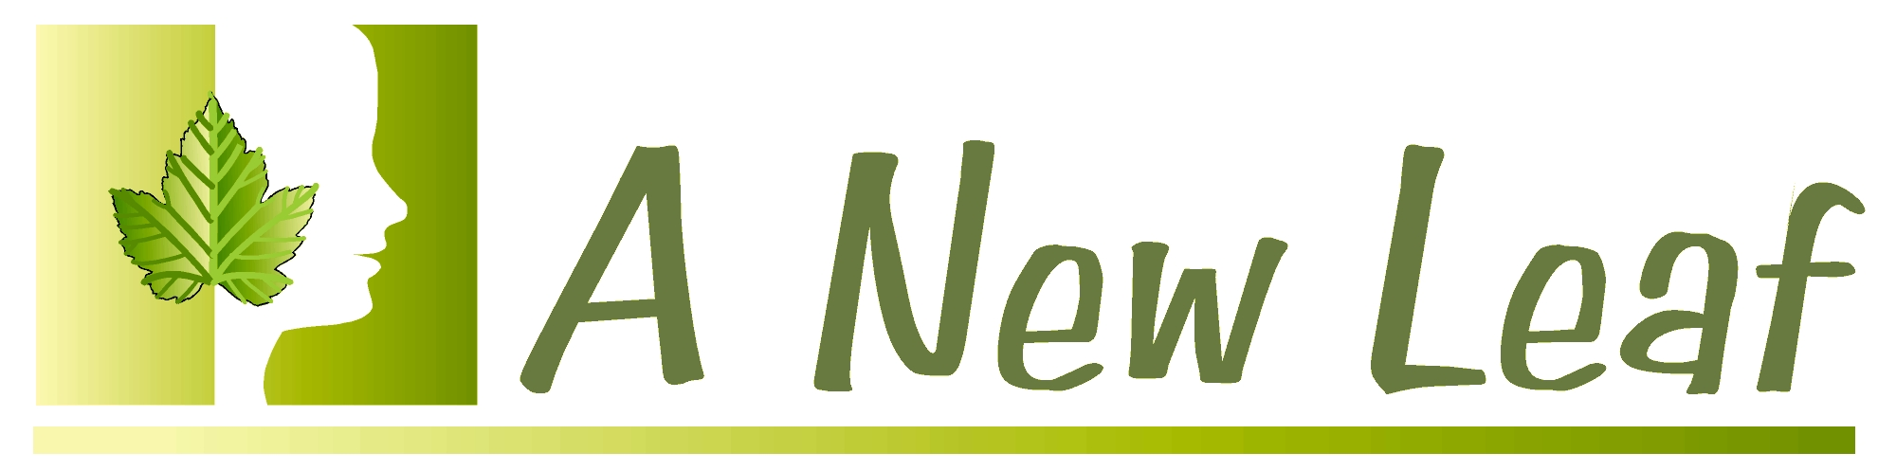

A New Leaf Hypnosis

Intake form for Weight Control

Date of intake: ___________

Age _________ DOB: _______ (Month/Day)

Name: ________________________________________________________

Street Address: _________________________
City_________________ State ______ Zip ________
Home Phone Number:________________________________________

Work Phone Number:________________________________________

Text Number if Available:________________________________________

What is the best way to reach you during the day?
___ Home Phone ____ Work Phone ___ Text ___ Email Number: ____________________________________
Email Address: ____________________________________
How did you hear about A New Leaf Hypnosis?

How would you describe your spiritual beliefs?
___ Christian
___ Jewish
___ Muslim
___ Metaphysical
___ Agnostic
___ Atheist
___ Other _____________
___ Prefer not to say

Height: _______ Current weight: ________

What would you like to weigh? ________

Have you ever been hypnotized before? Y/N

If so, what was your experience like?

Are there other things that you would like to work on sometime?

How have you tried to get rid of weight before?

Why didn’t it work?

How long have you had this excess weight? ________

When did you start gaining weight? _______

Do you remember what was happening in your life at that time?

Have you had times when you got rid of a lot of weight? Y / N

What was going on then in your life?

Why do you think you are overweight? (Why do you think you have been hanging on to this extra weight?)

Do you feel this extra weight could be helping you in any way?

If you got rid of the extra weight, how would that help you? What could you do and how would you feel that would be any different from now?
Name 7 Benefits of controling weight.
1.

2.

3.

4.

5.

6.

7.

Are there other habits you have that might be causing problems for you?

Your Eating Patterns
Do you eat out often? Y / N What types of restaurants/foods?

Do you go to fast food restaurants a lot? Y / N If so, what do you usually order?

What time do you usually eat dinner at? _________

What kinds of foods do you eat a lot of?

Are there foods that you “pig out on"?

In what situations do you get tempted to eat or snack? (Check all that apply.)
____ when you get home from work?
___ _in front of TV?
___ _ in bed?
____ after dinner?
____ with friends?
____ at sports events or other activities?
____ while reading or on the computer?

Other times?

When do you most want to eat (other than meal times)? (Check all that apply.)

____ when feeling lonely?

____ when feeling unhappy?

____ when feeling a lot of stress?

____ when feeling neglected?

____ when feeling depressed?

____ when feeling happy?

____ when you want to reward yourself?

____ when you're nervous?

____ when feeling bored?

____ when feeling frustrated?

____ when feeling anxious?

____ when feeling afraid?

____ when you feel you're not getting enough attention?

Other?

Do any of the following apply to you? (Check all that apply.)

____ eat too large a helping

____ eat too much sugar

____ eat too many fatty foods

____ don't eat breakfast, or eat something that's not nutritious

____don't exercise

____don't drink enough water

____ use too much salt

____eat between meals

____eat when not really hungry

____ eat too fast

____eat a lot of fast foods and/or junk foods

____ eat very few fresh or frozen vegetables and fruits

Is there anything else you can think of?

Do you like vegetables? Y / N Fruits? Y / N How often do you eat them?

Exercise Habits

Do you exercise? Y / N How frequently? ________ What kind of exercise?

How do you feel about exercise?

What type or types of exercise would you like to do?

Is there anything else you feel is important for me to know about your habits and beliefs that can help you meet your goal of becoming your ideal goal weight?

Weight Loss Goals

Please place a mark next to the statements below that are true for you. Then, go back through the list,and circle the four or five changes that you would MOST like to make to help you toward your weight loss goal.

____ I would like to exercise more.

____ I would like to drink more water.

____ I would like to feel more motivated to consistently do the things I need to do to become slimmer.

____ I would like to really believe that I can release weight.

____ I would like to be able to reduce the amount of food I eat at meal time.

____ I would like to eat healthy snacks in between meals.

____ I would like to be able not to snack on junk food so much at home, because that is one of the main problems (i.e.,eating while reading, watching TV, or working at the computer).

____ I would like to be able not to snack on unhealthy food at work, because that is one of the main problems.

____ I would like to be able to resist salty or sweet snacks, or just eliminate them completely.

____ I would like to cut down on the amount of alcohol I drink. Those drinks are so fattening.

____ I believe I am over weight because of my mother or father, etc.

____ I normally eat breakfast, but this is not always true. I have heard that breakfast is the most important meal of the day. But it seems (to me) if I eat breakfast, I am hungry all day long.

____ Sometimes, I eat when I am not really hungry. What percent of food do you believe you eat because of true hunger? ________%

____ I sometimes eat when I feel bad (boredom, depression, anxiety, stress, loneliness, or sad, etc.)

____ I sometimes eat when I feel happy and want to celebrate, reward myself, or to be social, or just because the clock says that it is time to eat.

____ I have another reason I eat in a way that is preventing me from becoming as slim and lean as I would like to be.

Why I Want to Be Slim and Healthy

Now place a mark next to some of the reasons you want to release excess weight. You can add other reasons at the end of the list. After all, the purpose of this form is to learn more about how I can help you.

____ I would have better health.

____ I would have more energy.

____ I could fit into those clothes I wish I could still wear.

____ I can improve my career opportunities.

____ I would like to make the clothes I have fit better.

____ I would have more self-confidence.

____ I could improve my relationship.

____ I would feel better about myself.

____ Shopping would be more fun.

____ I would look and feel better in a swimsuit.

____ I want to look good for a special occasion (i.e. wedding or vacation).

If yes, what occasion or event and when is it taking place? _________________

____ Almost everything in my life would be better.

____ If I could release this excess weight, I would feel more self-confident and be a better example to others.

Please describe to me what type of imagery is most relaxing to you – whether it be indoors or in nature, at the ocean, in a meadow, a forest – whether you prefer imagery which includes bright sunlight and warmth or cool breezes, etc. If it’s easier, feel free to bring in photographs of your favorite imagery. You may also let me know if you find it easy or difficult to visualize, or if you prefer simply imagining your peaceful place.

What are your hobbies / interests?

Do I have permission to touch your hand, arm, shoulder? Y/N

